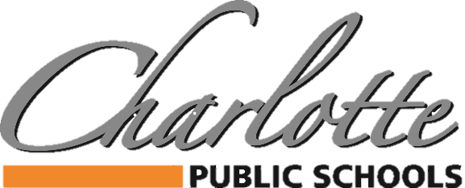

Charlotte Public Schools SEL Support Dog Notice
Charlotte Public Schools will be implementing a SEL Support Dog program during the 2023-2024 school year at your child’s school. Research has shown that support dogs in schools can help build strong social emotional skills in students. A support dog presence has also been shown to reduce anxiety, help students work through anger management concerns, reduce bullying tendencies, and address other personal and social issues that all of our developing students deal with. There are specific goals of the SEL support dog program and they include but are not limited to: increase empathy and compassion in students; help students connect with something in the school setting and reduce anxiety; and improve academic performance, while increasing confidence and self-esteem.
Our SEL support dog will be trained and certified through Canines for Change. Our dog has passed a temperament evaluation for suitability to become certified and to work in a variety of settings around people.
Our SEL support dog is owned by Charlotte Public Schools and is cared for by our employees. Each SEL support dog has a Host that takes care of them while they are not at work and a Handler that cares for them while at work. Both the Host and Handler have been properly trained through the Canines for Change program and meet very strict requirements for the ongoing care of the dog and the conditions under which our dog works.
You will find attached to this letter more specific information about the SEL support dog assigned to your child’s building including: name, age, breed, size, Host name and Handler name. It also includes a list of expectations for students when interacting with the SEL support dog. We encourage you to review these expectations with your child.
Please complete the form below acknowledging your preference as to whether you wish your child to have contact with a CPS support dog. If we do not receive a response from you within ten (10) business days we will automatically assume you do not have any concerns and approve interaction between your student and the SEL support dog. Please contact your building principal if you have questions regarding this program.
-------------------------------------------------------------------------------------------------------------------------------------
Student’s Full Name: Grade:
I understand that my child may have incidental or student-initiated contact with the SEL support dog. I understand that the SEL support dog may be in my child’s classroom and may be part of the student support process. I understand that this permission form will remain in effect for the current school year. If I should change my mind regarding my child’s interaction and participation with the SEL support dog, I understand I must provide notice in writing to my child’s principal.
Yes, my child may have contact with the SEL support dog.
No, my child may NOT have contact with the SEL support dog.
Due to Allergies Due to Fear of Dogs Other
Parent/Guardian Signature: Date:

